CHAPTER 5: Chemical reactions
Worksheet 5.7

Speeding up reactions
Student: Class:

Boiling the billy
1. Making a pot of tea at a camp fire is known in Australia as ‘boiling the billy’. The camper wants to boil the water faster. An increase in the rate of wood burning will deliver heat to the water faster.
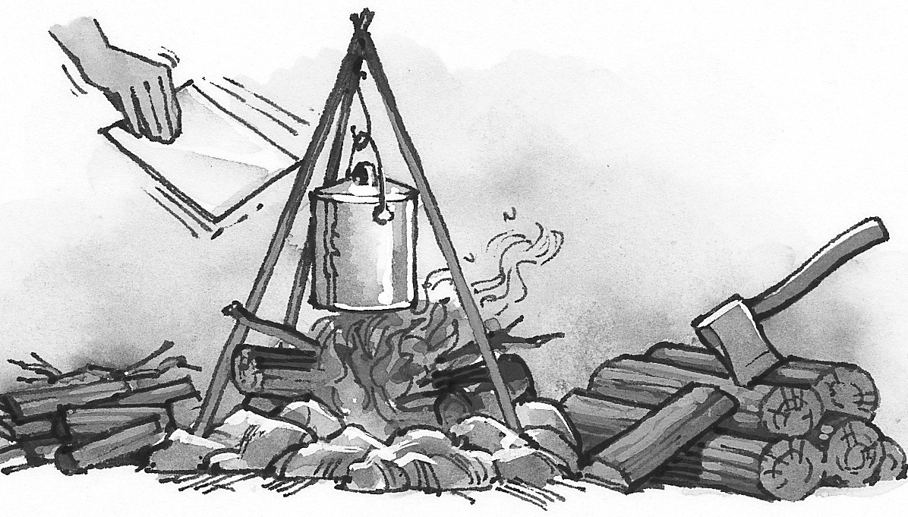 | (a) One method of increasing the combustion of the wood is to add more reactants. How is the paper fanning doing this?  (b) Increasing the surface area of the wood also helps. How has the camper achieved this?

Changing the speed of the reaction
2. Calcium carbonate is the main chemical present in limestone. When hydrochloric acid is added to lumps of calcium carbonate, it fizzes and dissolves to form calcium chloride and water; gaseous carbon dioxide is also formed. The calcium chloride remains dissolved in the acid.
(a) Write a word equation for this reaction.

(b) A student used the following apparatus to study the speed of the reaction.
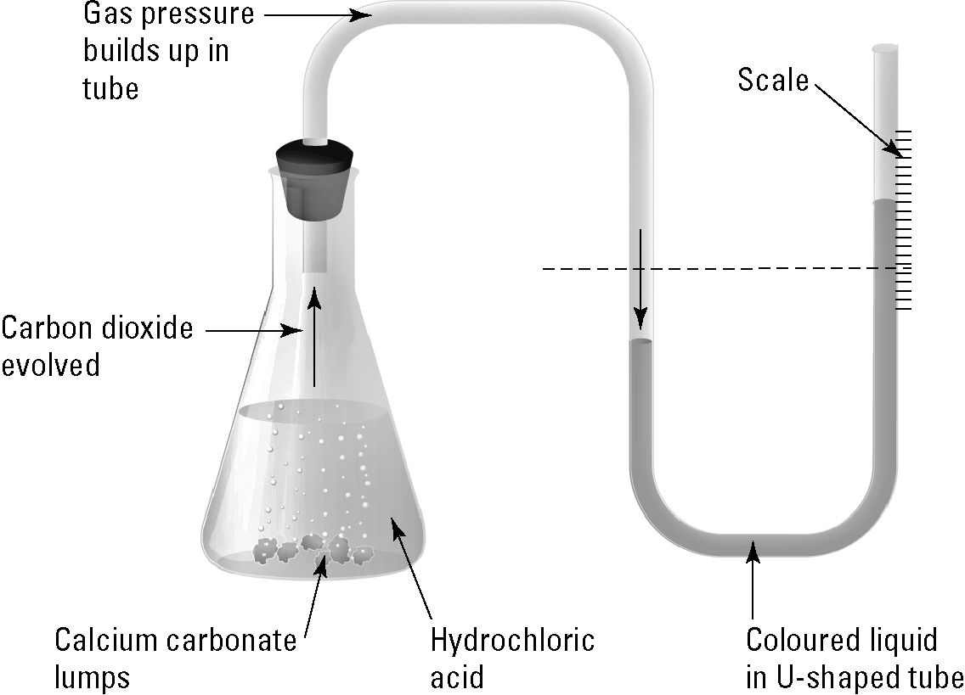 | (i) Explain how the apparatus can be  used to measure how fast the calcium carbonate is dissolved in the acid.
(ii) Compare the observations when the experiment is repeated with powdered calcium carbonate instead of lumps of calcium carbonate.

(iii) The student heats the flask to a higher temperature. How will the observations change compared with the experiment at room temperature?

